I

John Green

2. Design and Develop a Website

Contents

Task 1 2

Introduction 2

Project Brief [P2] 2

Designs [P2] 2

Site Map 2

Wireframes 2

Justifications for Designs [M2] 2

Feedback on Designs [P3] 2

Website Production [P4] 2

Testing [P5] 2

Optimisation [M3] 2

Task 2 2

Evaluation [D2 only] 2

Reflections [D3 only] 2

Individual responsibility 2

Creativity 2

effective self-management 2

Review [P6] 2

## Introduction

For this assignment, my task set by Pansy was to create a website focused around her and her garden services. The website content has already been provided, but the website was not designed or developed.

## Project Brief [P2]

The project brief is a piece of documentation outlining the necessities behind the whole project. It includes what we need to do and what we need to be able to complete the assignment.

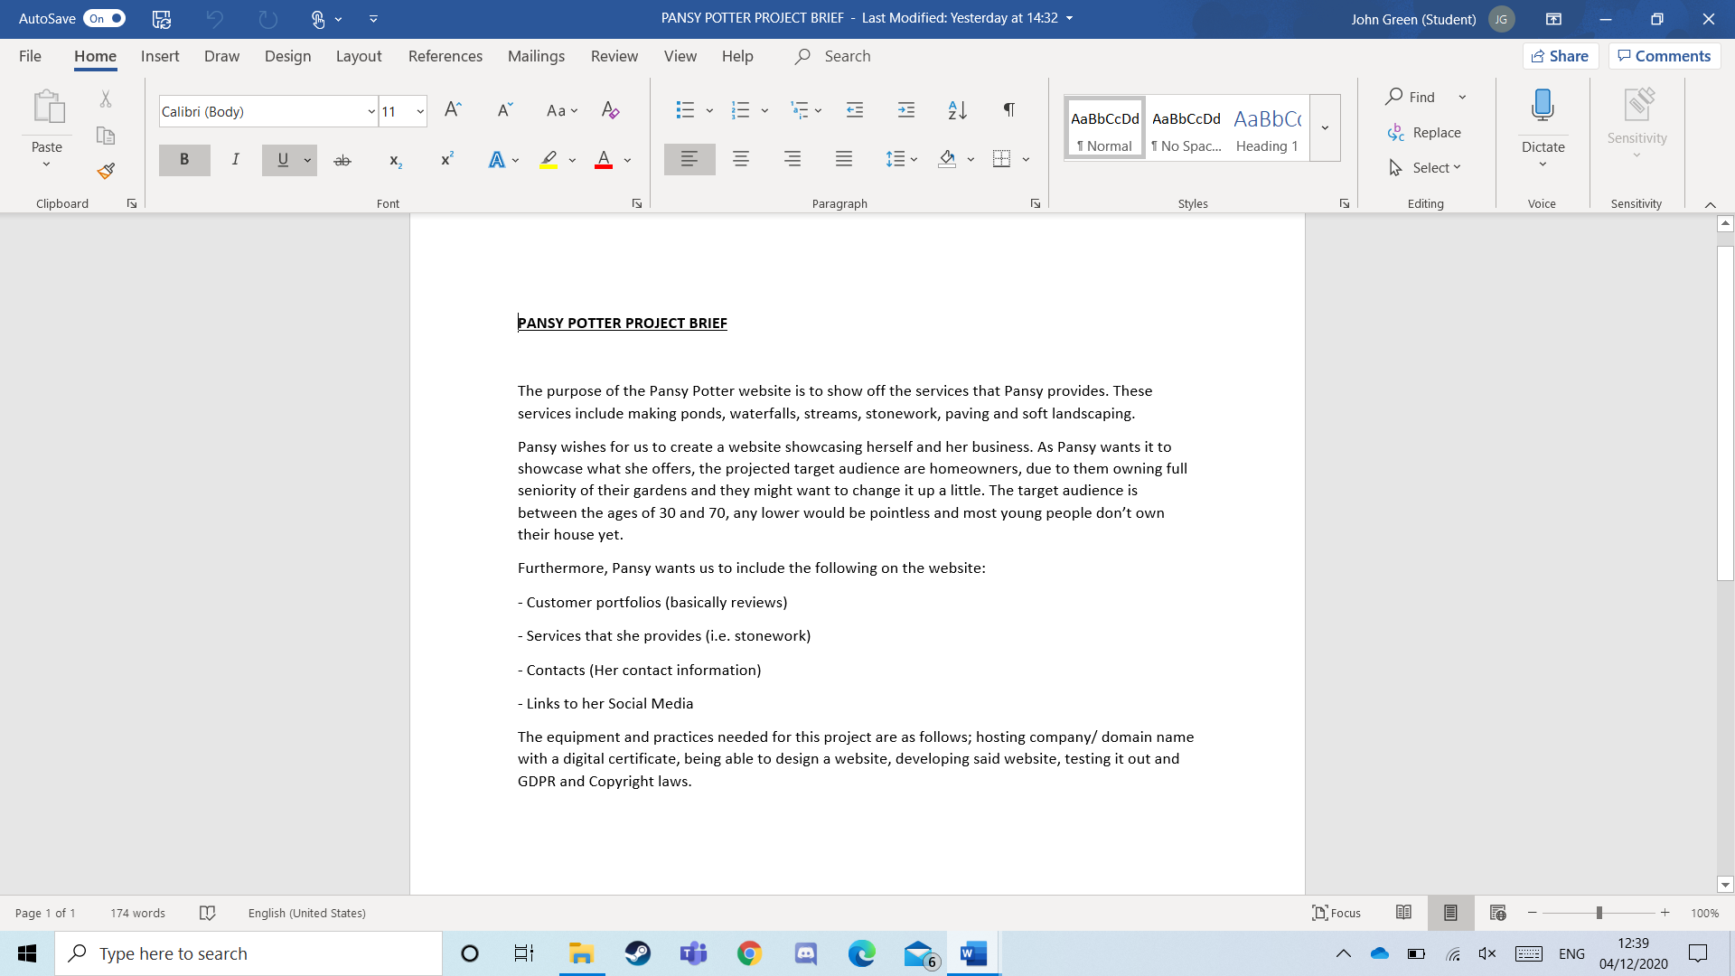

## Designs [P2]

### Site Map

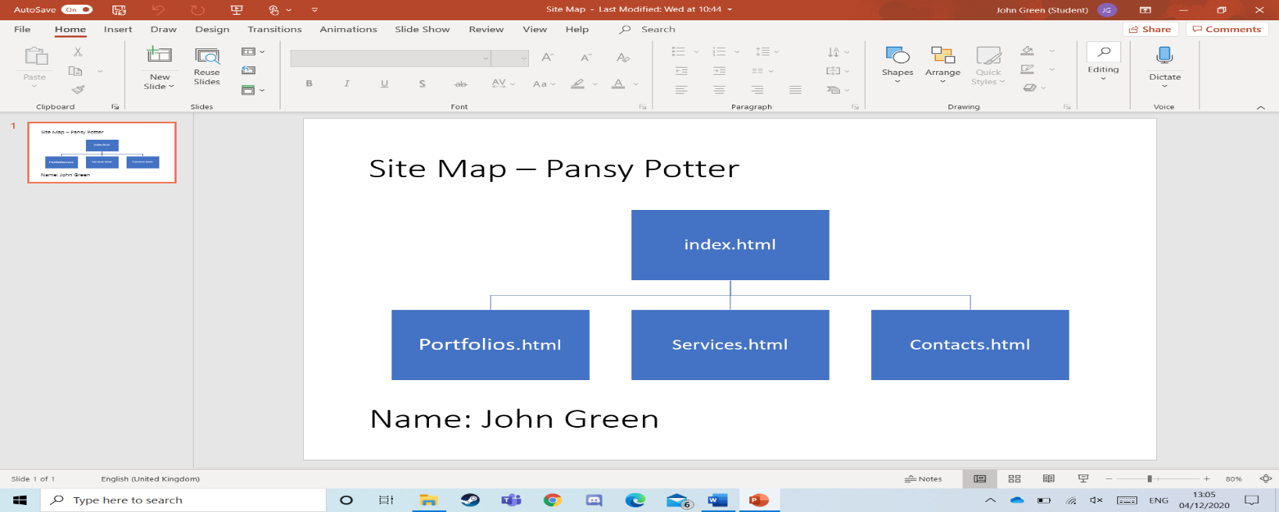A site map is a diagram outlining the list of webpages inside a domain.

### 

### Wireframes

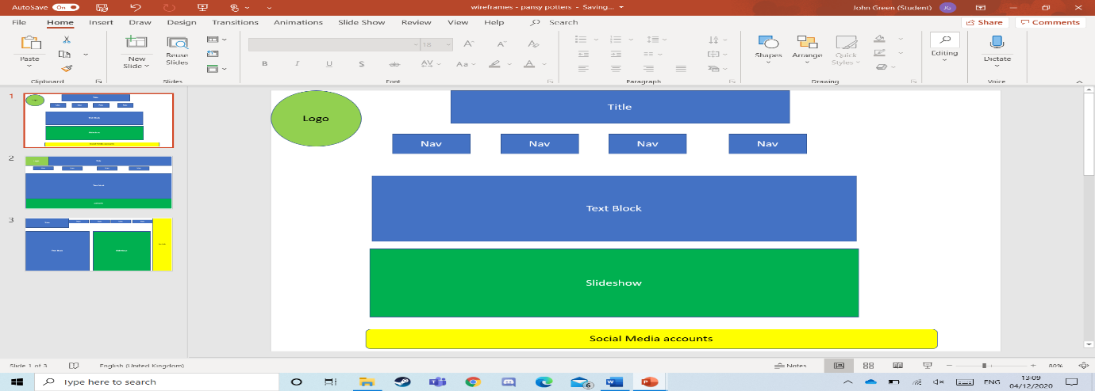A wireframe is a light design/plan on what the website may look like. I made the following:

## 

## 

## Justifications for Designs [M2]

Out of the three designs, I decided to choose the second one. This is because I believed it was the best choice.

By having the logo in the top left, it increases chances of being seen as it’ll be the first thing they see. Also, it will be out of the way of the website content, which will make the website look more presentable and professional. In comparison, the third design doesn’t even have a logo.

Having the title at the top is beneficial as people will know what they are on instantaneously. Furthermore, the third design has the title covering the top left, thus covering up any logo space. Also, most titles are top-centre, so having it top-left might scare people off as it looks poor.

Having the bulk of text be placed in the centre makes it quite easy to read as it most of the page will be displaying it. The pictures underneath it are placed well because the text talks about them. So, by having the images below the text allows the visitors to read and then view, which will make the text make sense. Having pictures and then text following on would be confusing to me.

## 

## Feedback on Designs [P3]

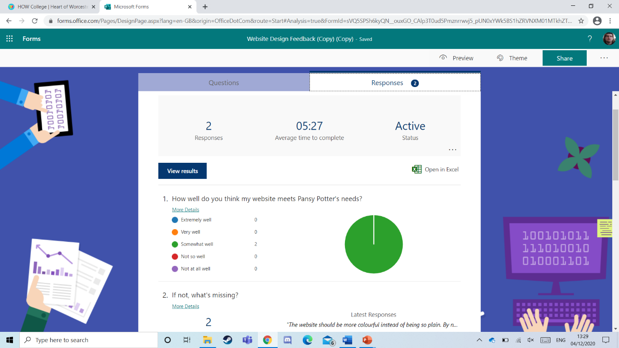The early version of the website had been reviewed by Thomas Gorton and Rad. They both agreed that my website meets Pansy’s needs to an extent.

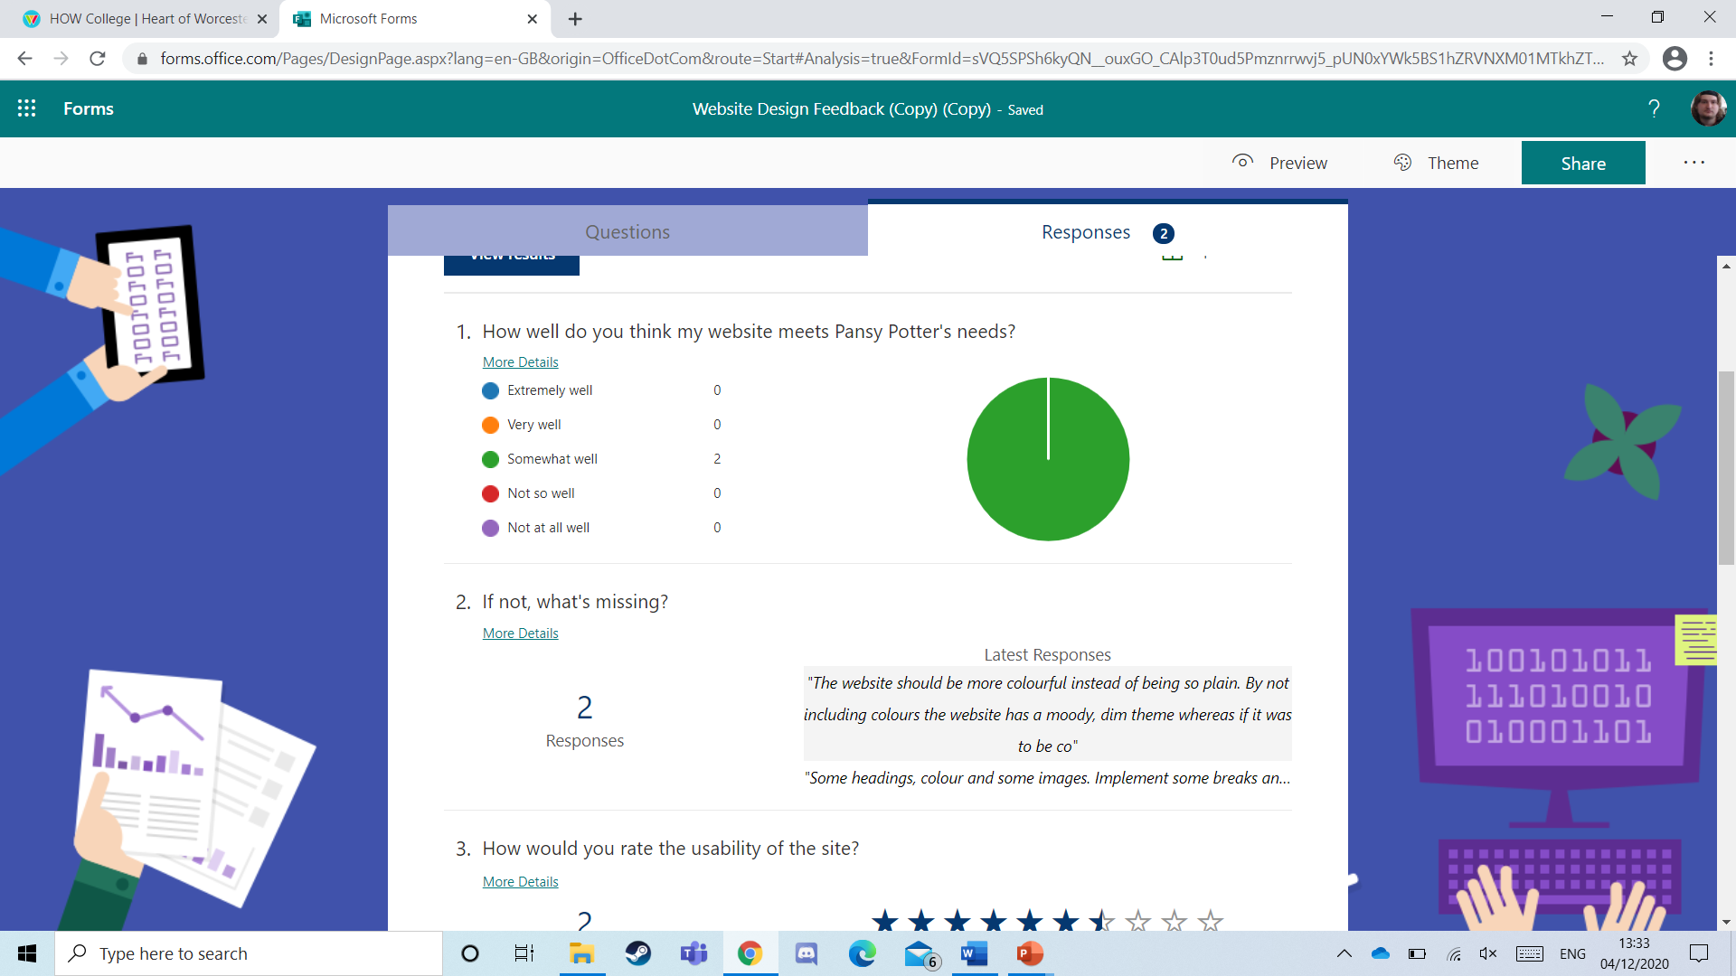They also gave me some pointers on what to add:

(the second comment ends with “and a footer”.)

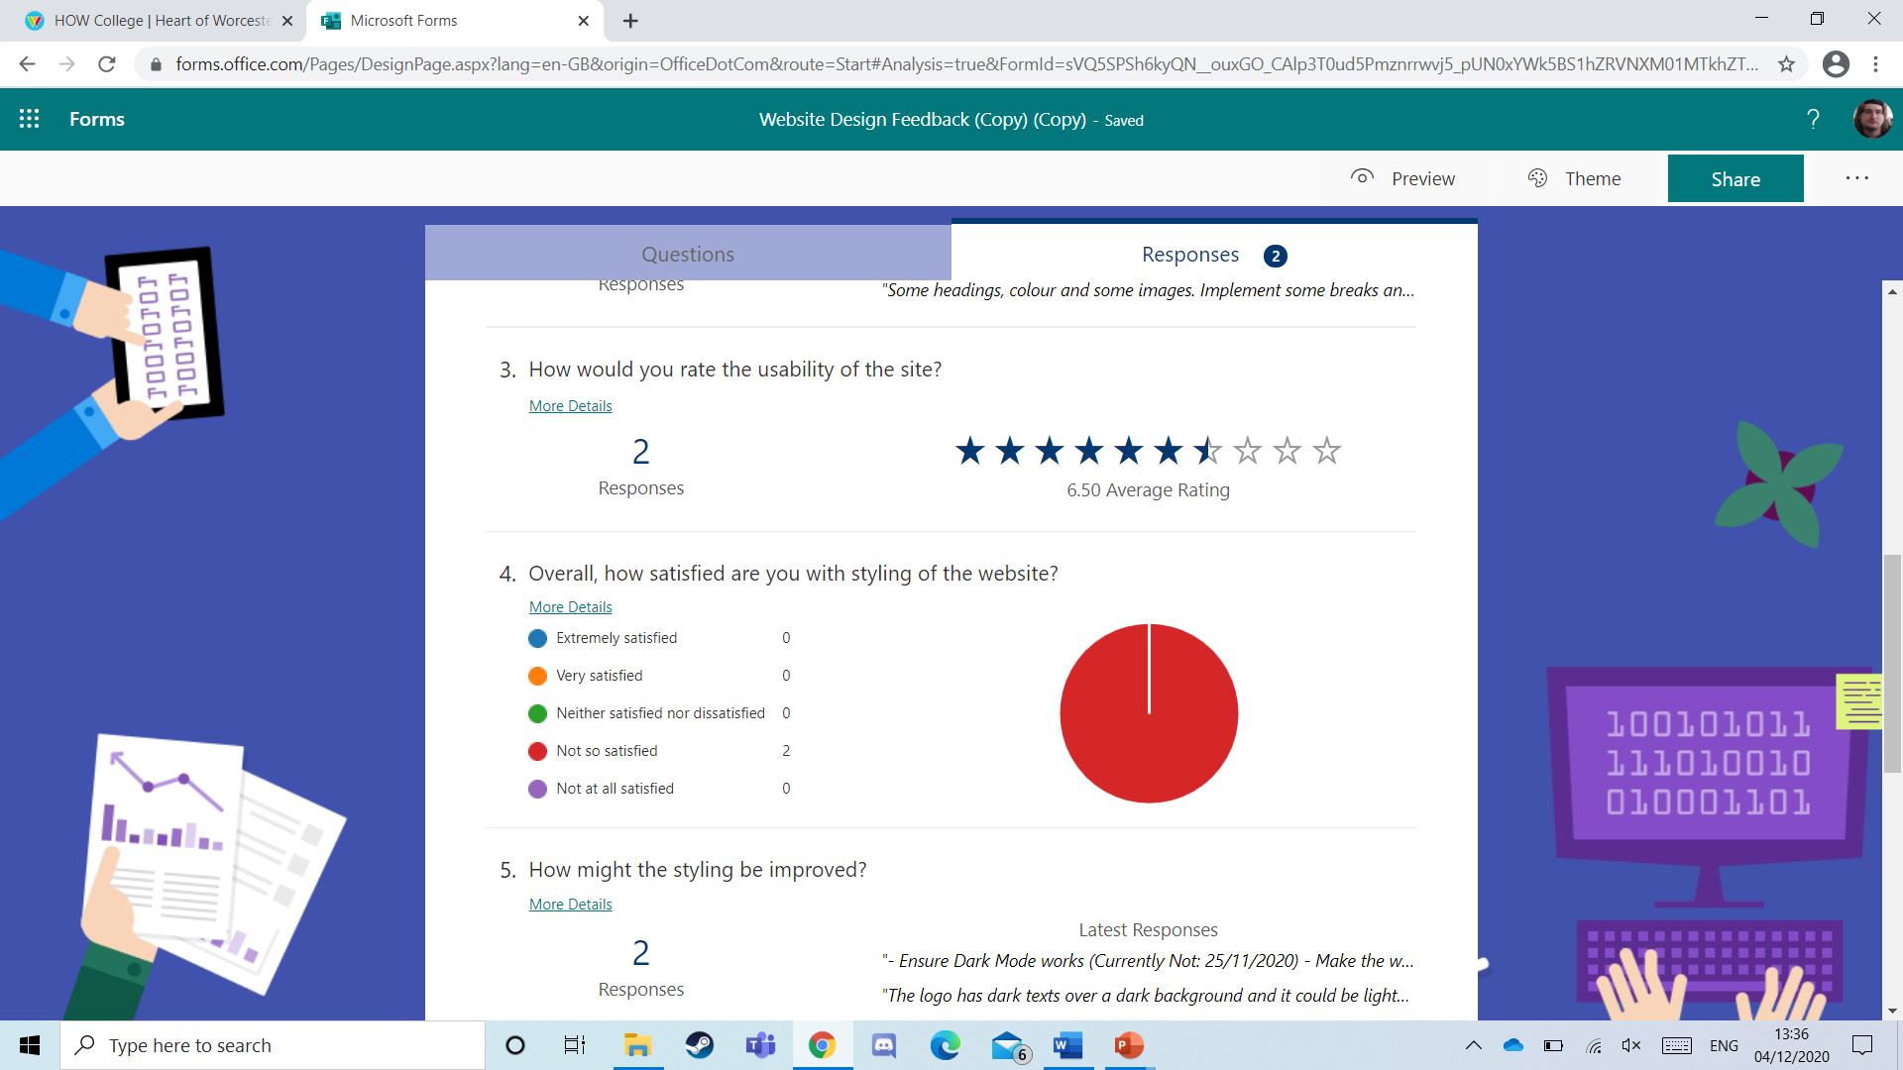They gave an average rating of 6.5 stars out of 10 and stated that they weren’t happy with my design.

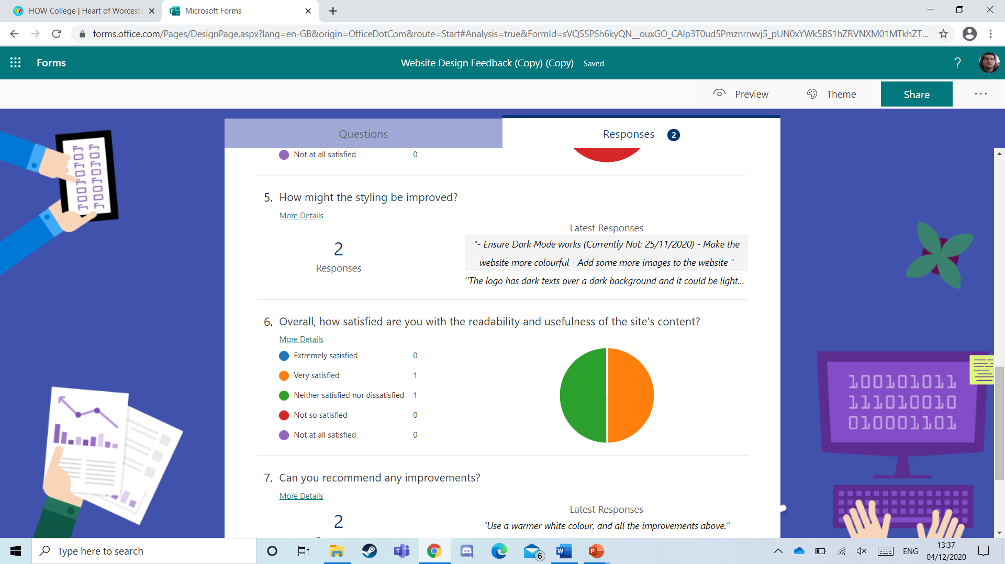The advice they gave me on improvements were:

(The second sentence ends with “Paragraphs could be broken down”.)

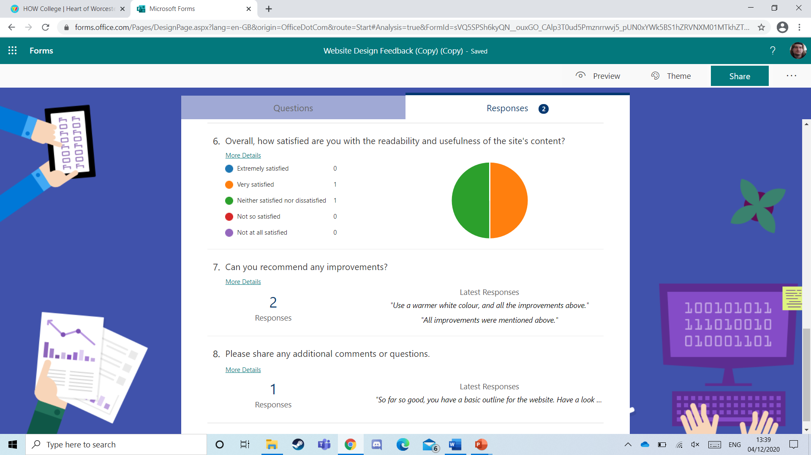The satisfaction level they gave me:

Improvements needed, and comments:

After getting this feedback back to me, I went away and made improvements immediately.

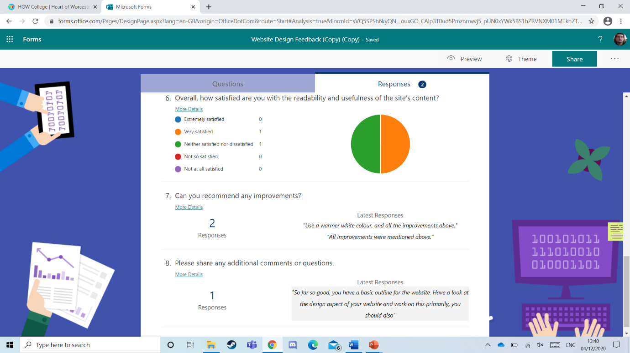

## Website Production [P4]

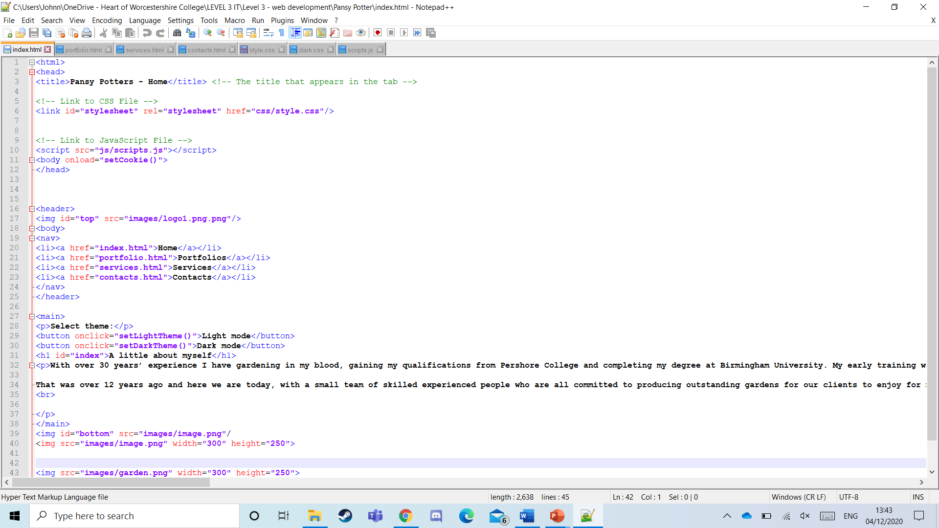 **These two screenshots are showcasing the html code used to make the home page.**

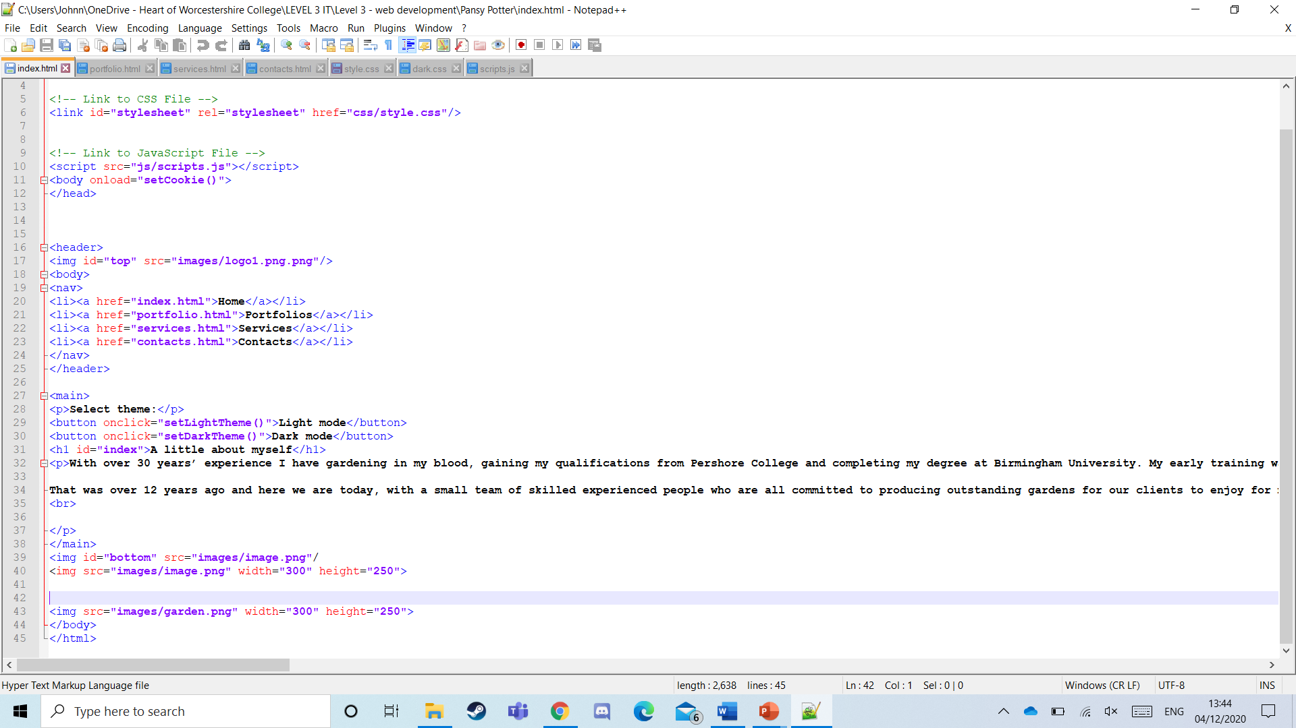

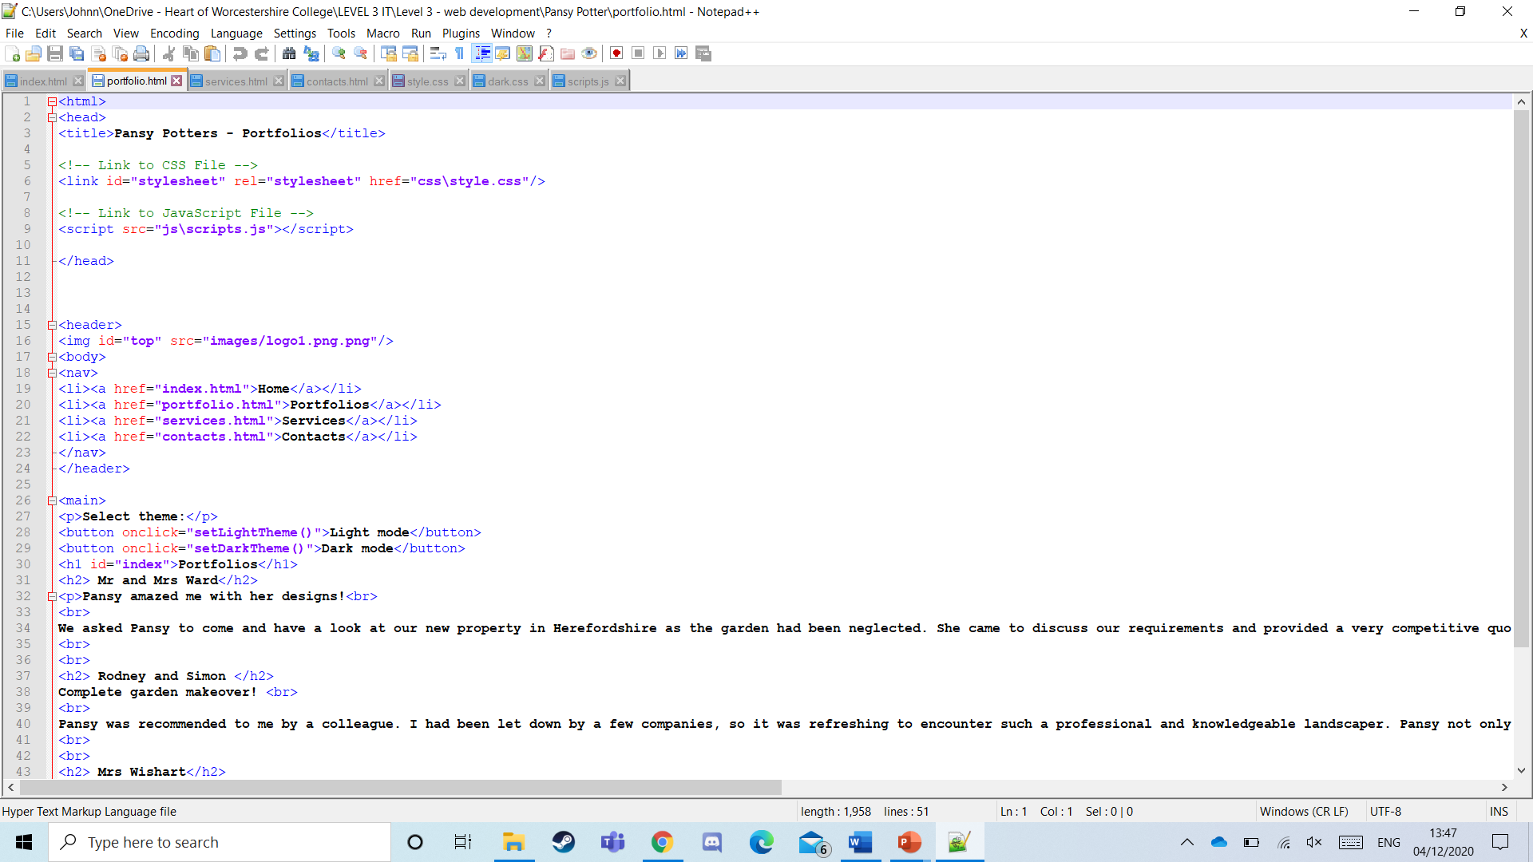**These two screenshots are showcasing the HTML used for my portfolio page**:

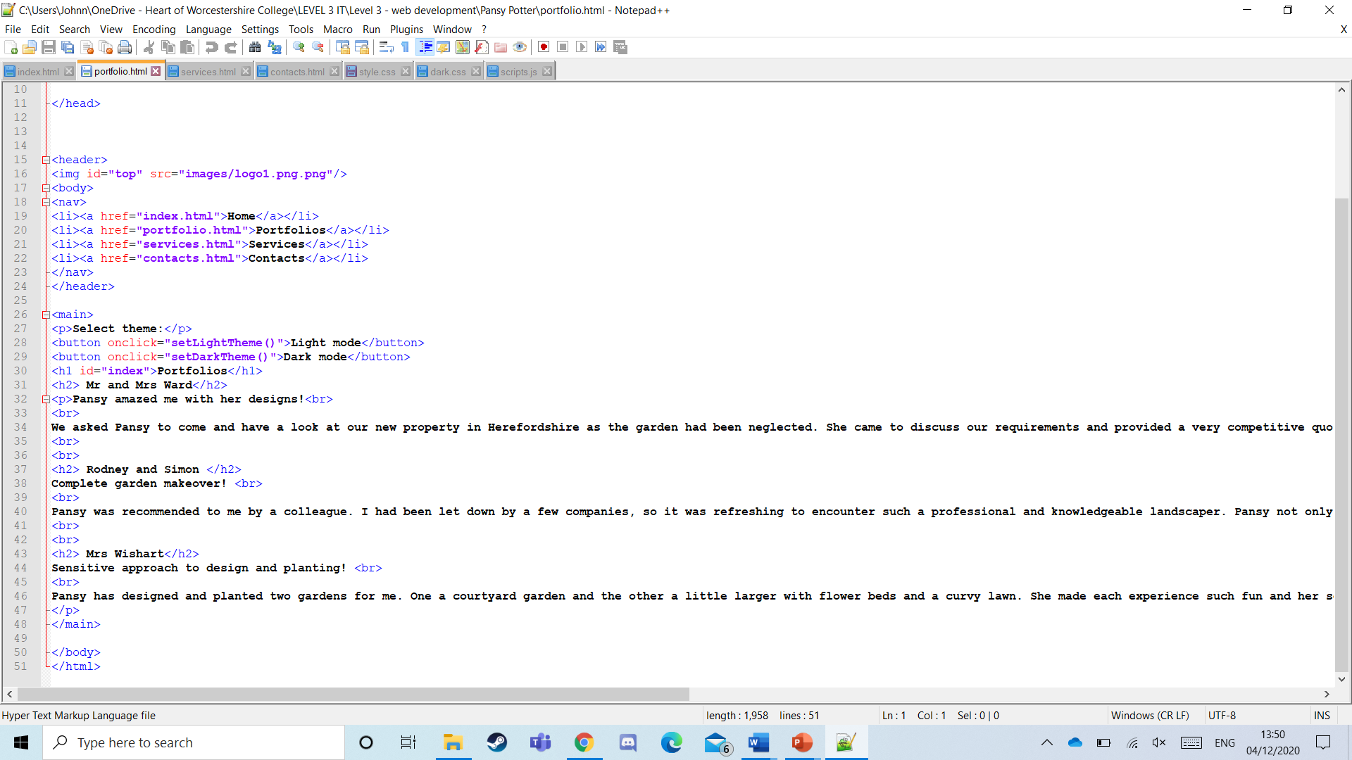

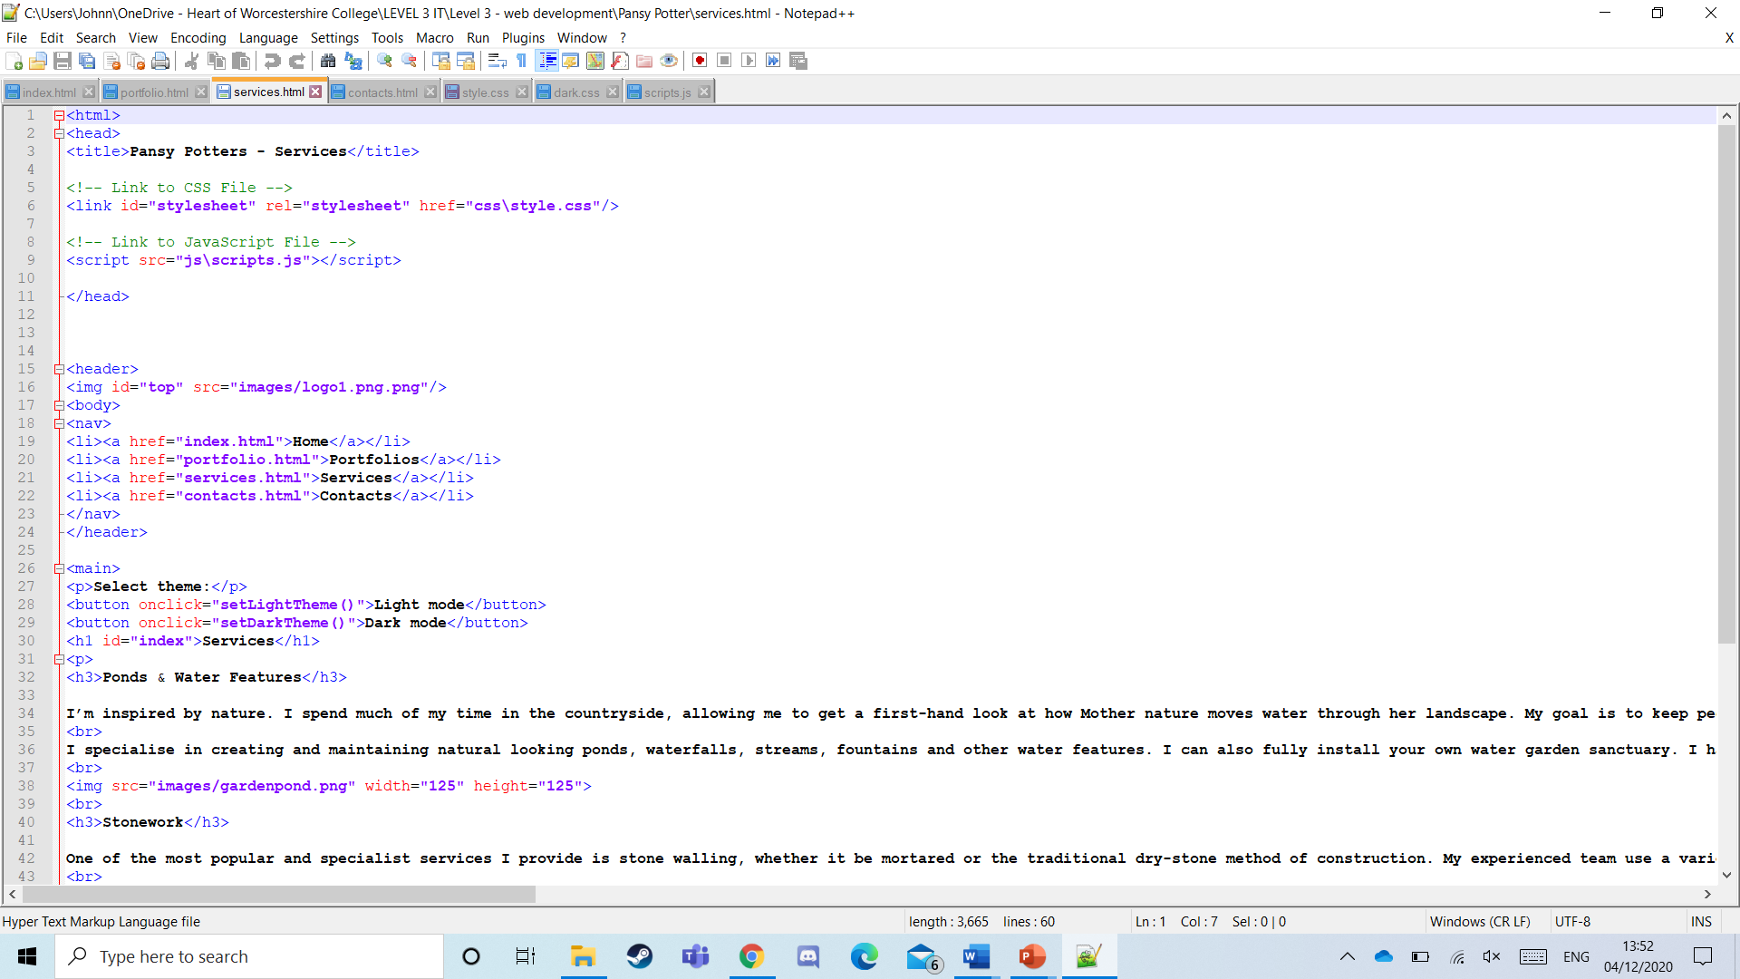**These two screenshots are showcasing the HTML for the services page:**

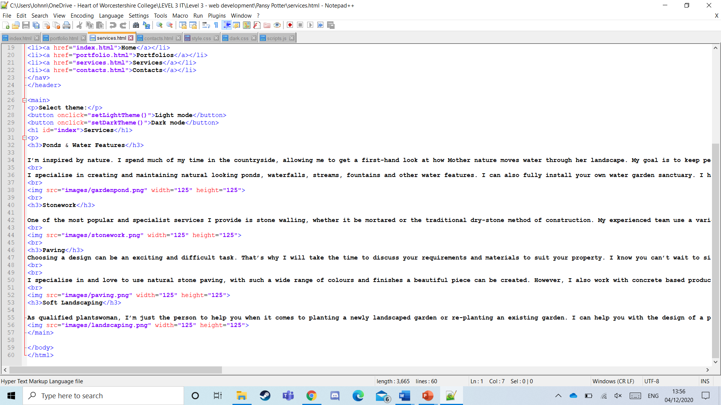

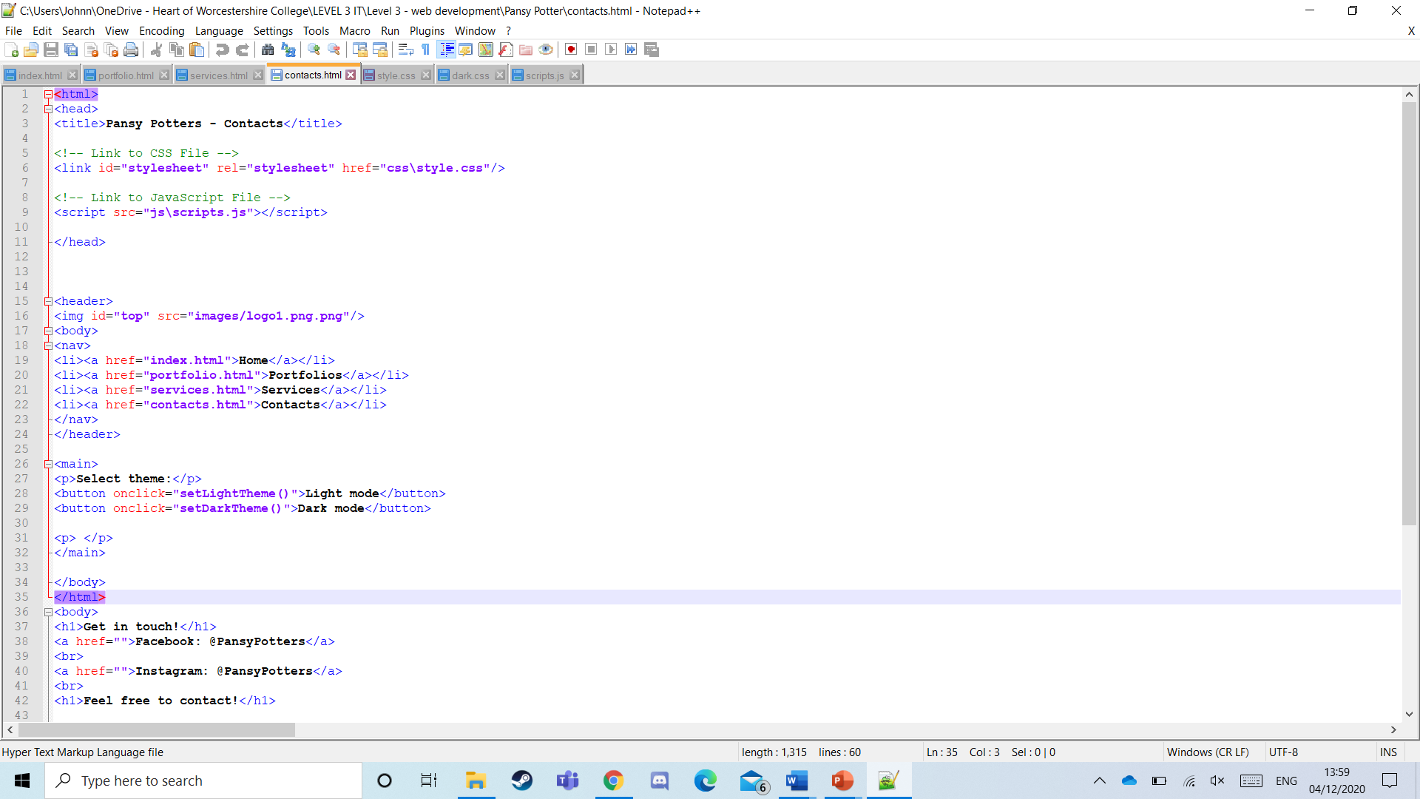**These two screenshots are showcasing the HTML for the contacts page:**

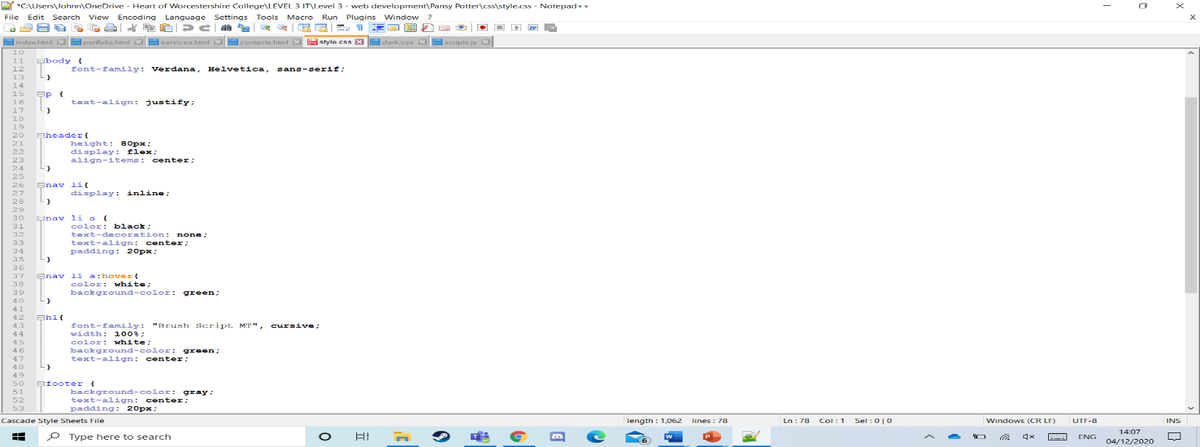**These 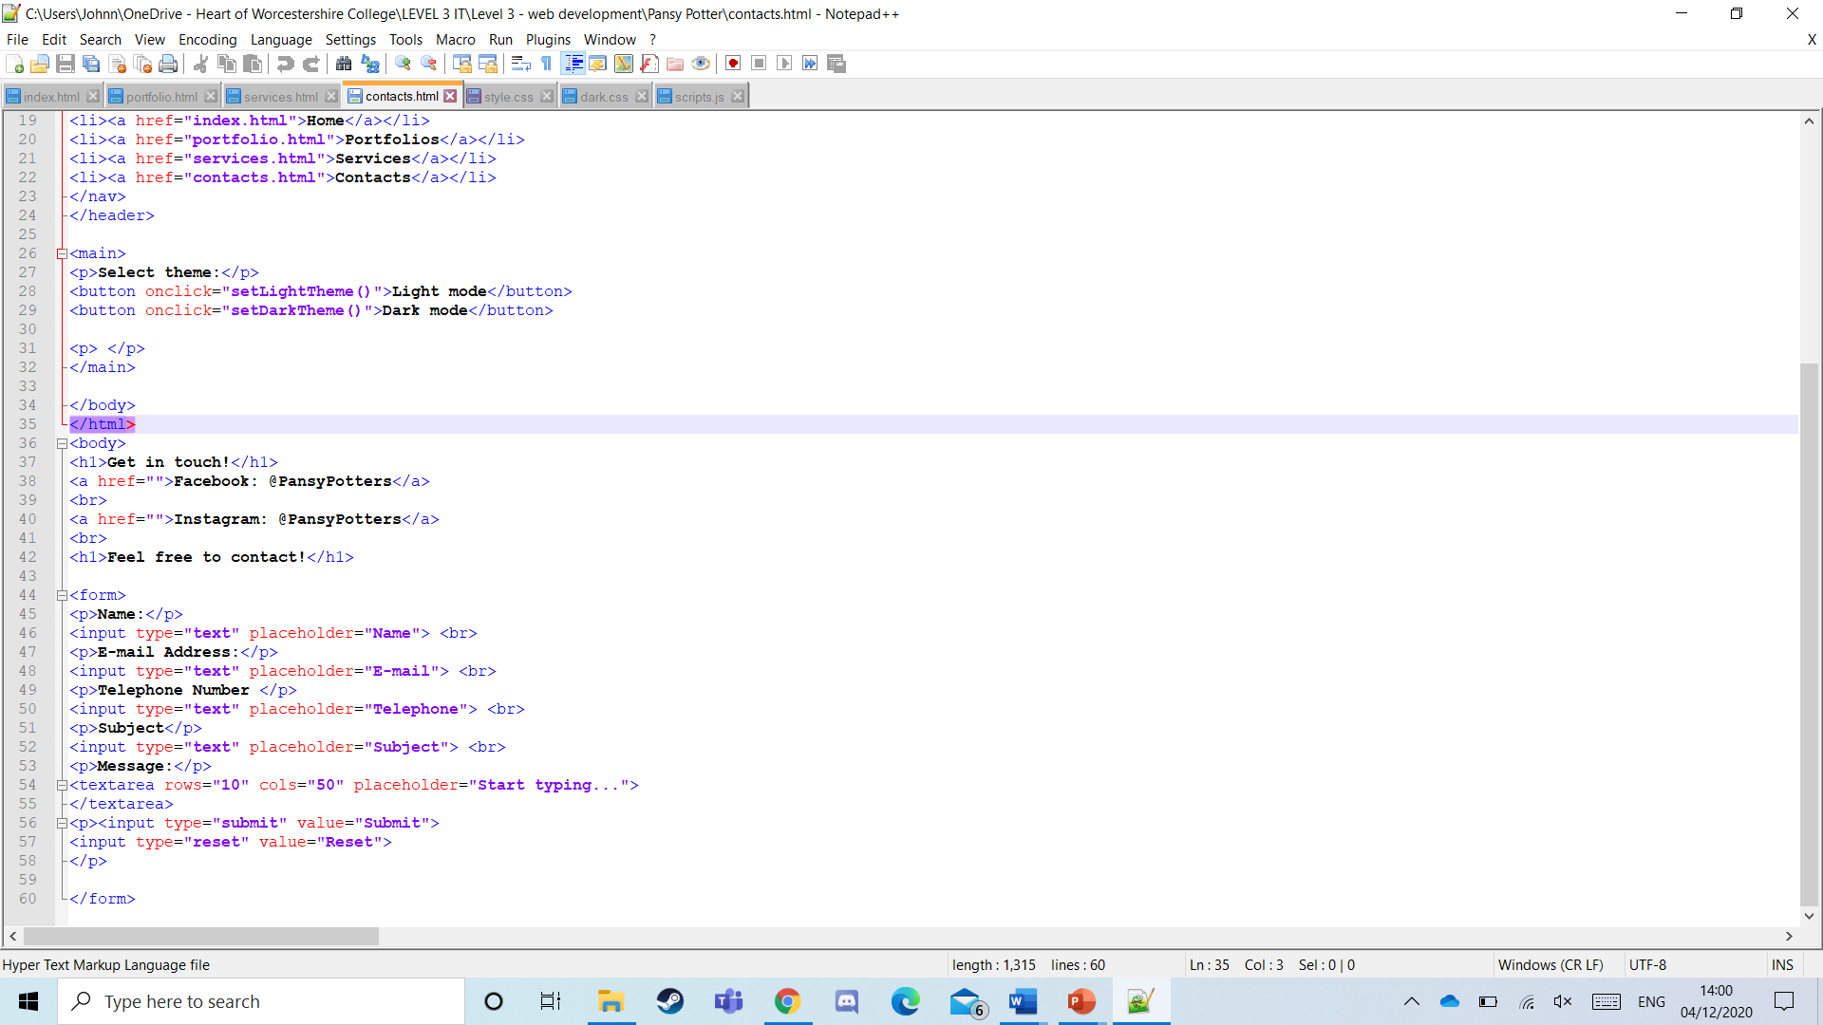screenshots are showing the css style for light mode:**

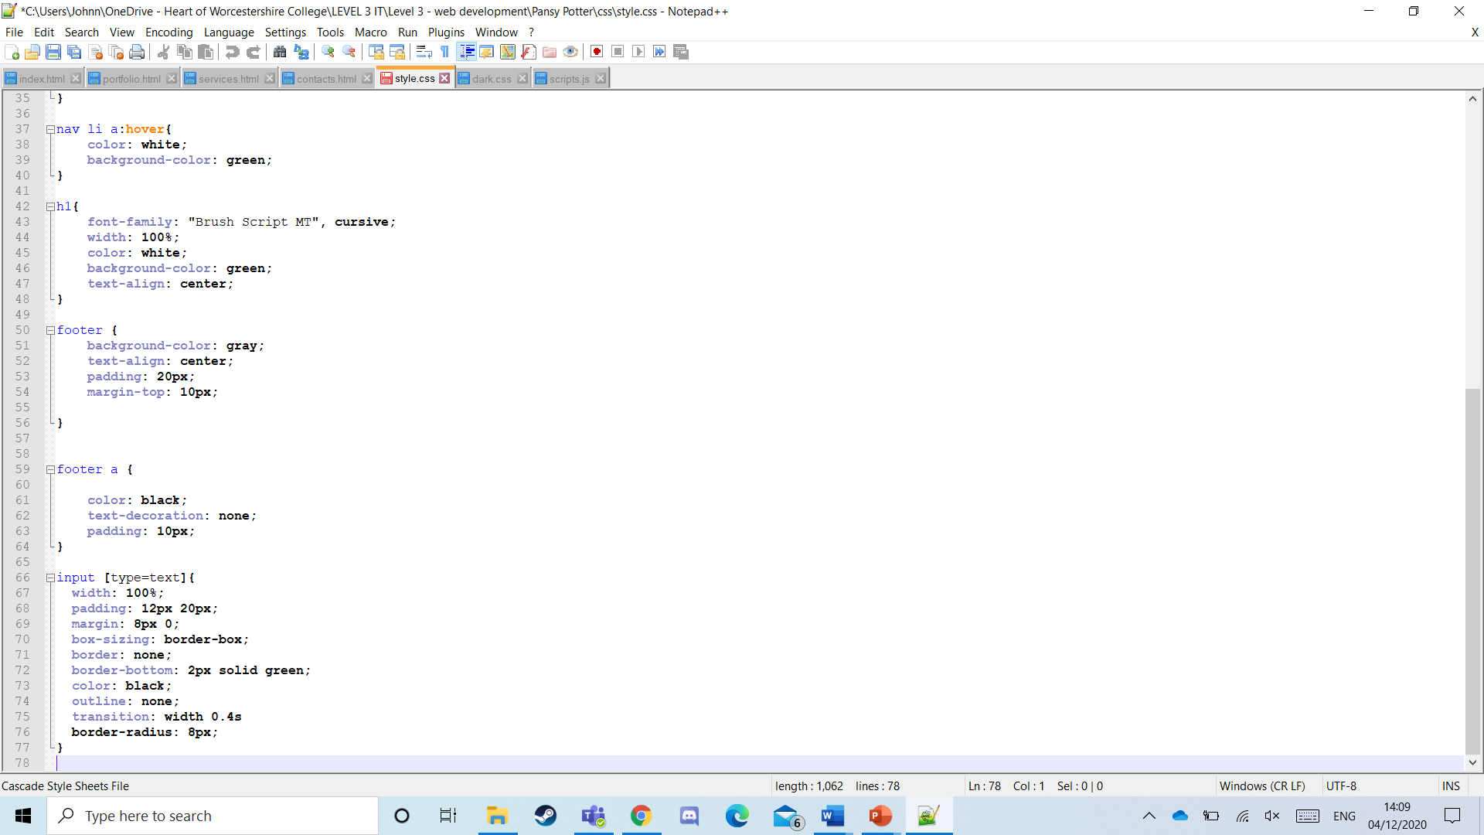

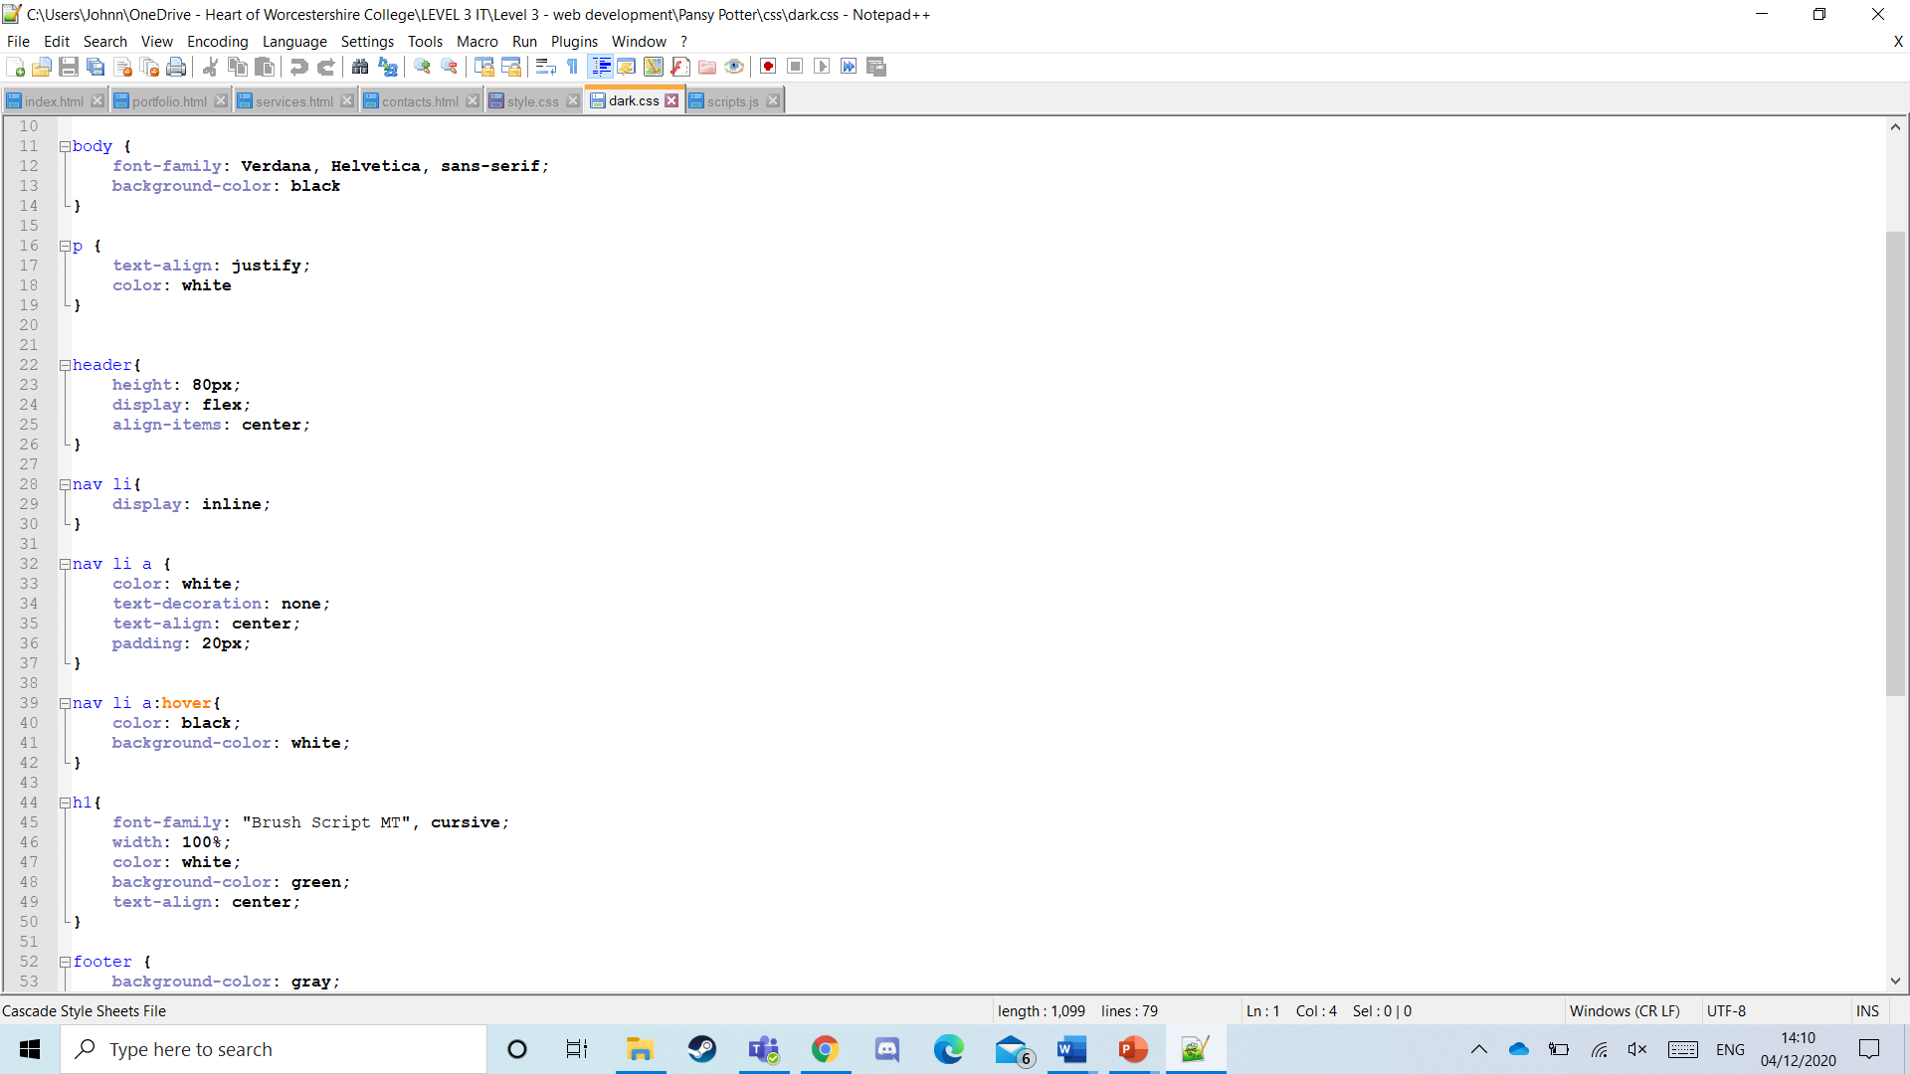**These screenshots are showing the css for dark mode:**

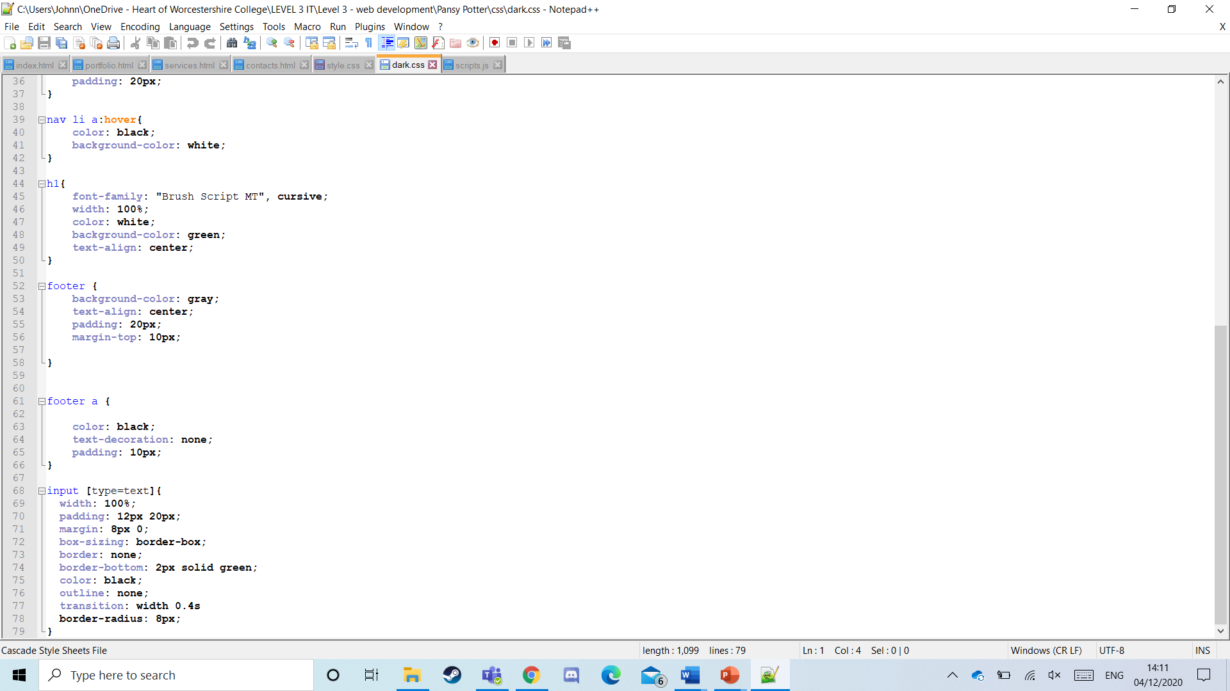

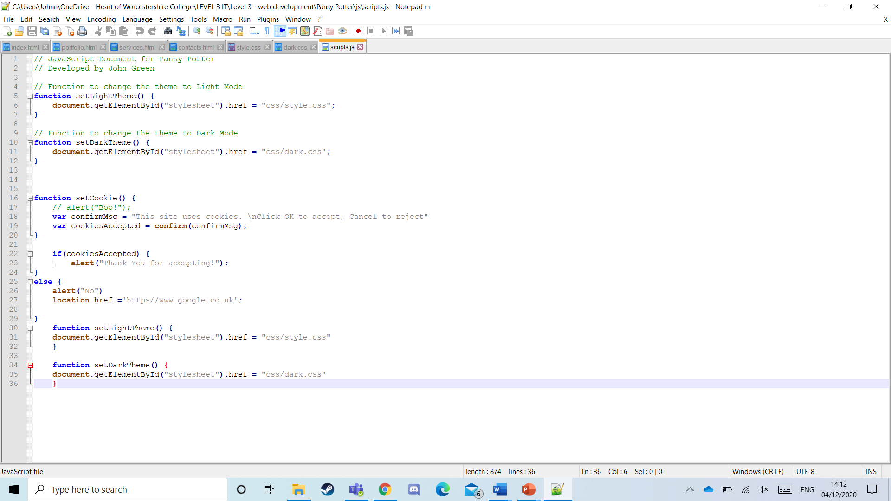**This screenshot is showing the JavaScript:**

## Testing [P5]

## 

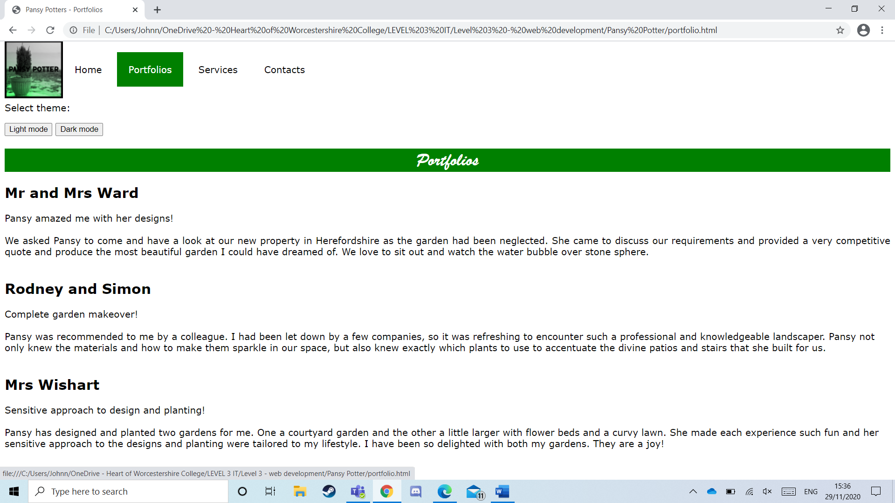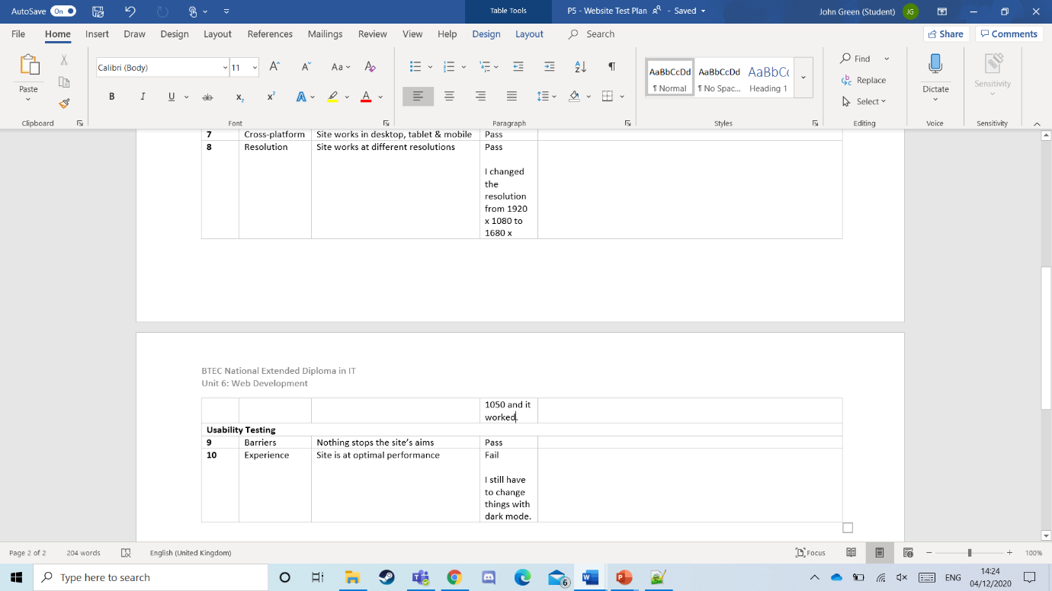(**Test plan images**)

1. 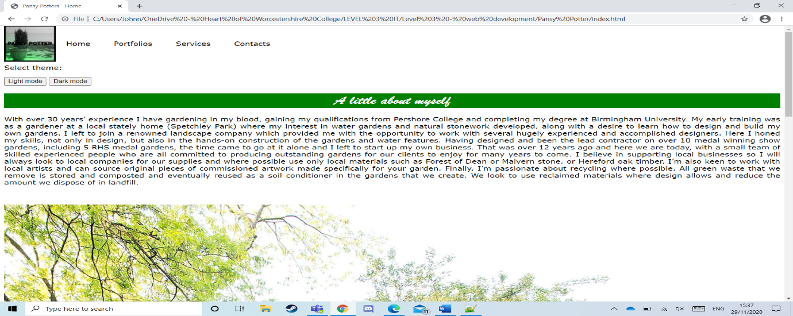

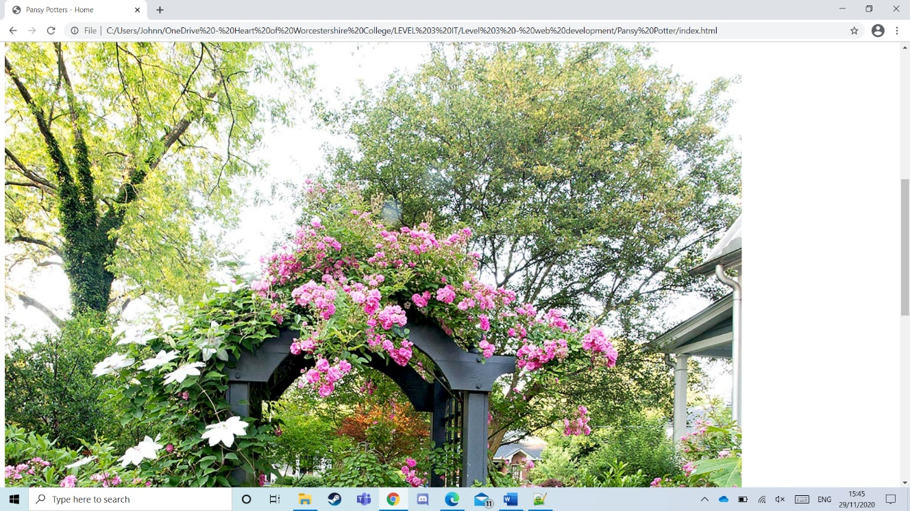**3)**

Fail: pic too big

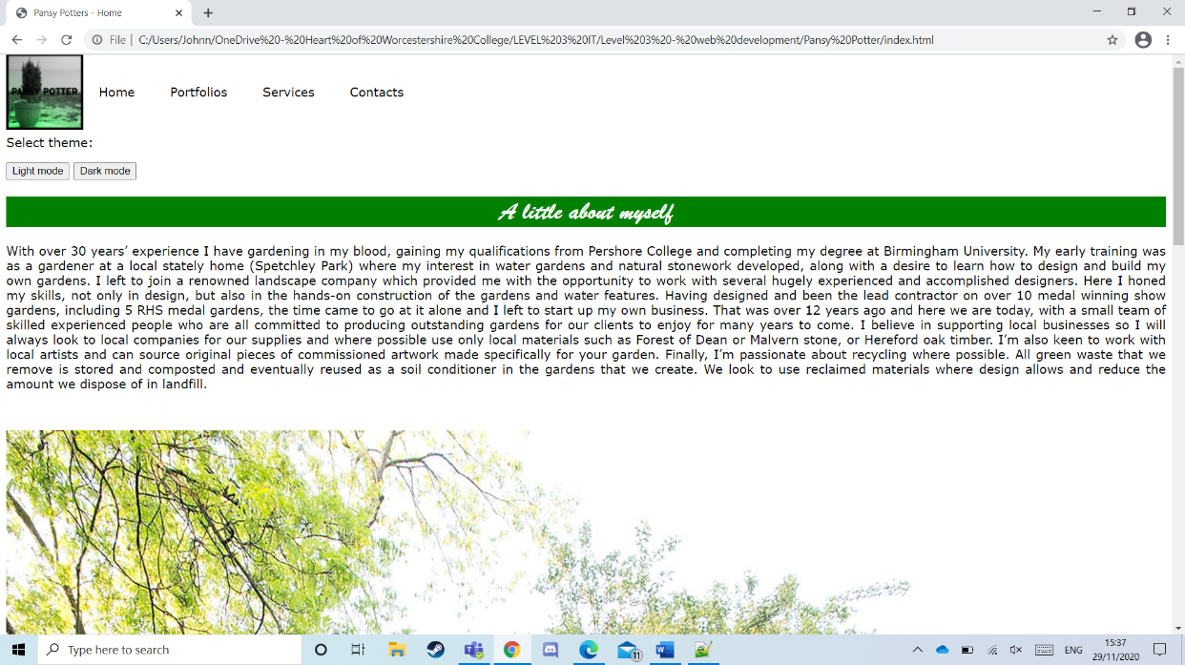

**4)**

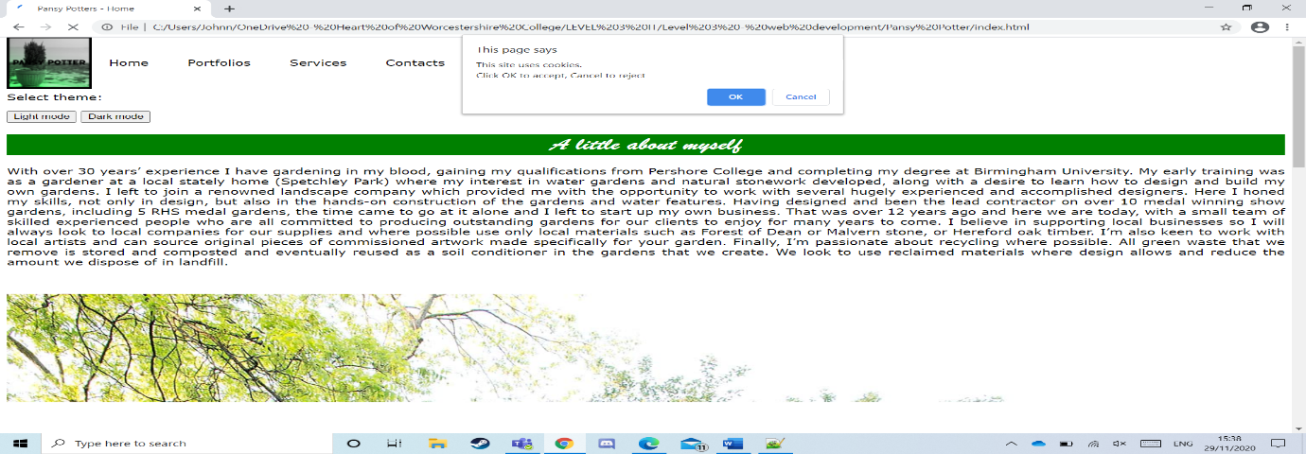

**5)**

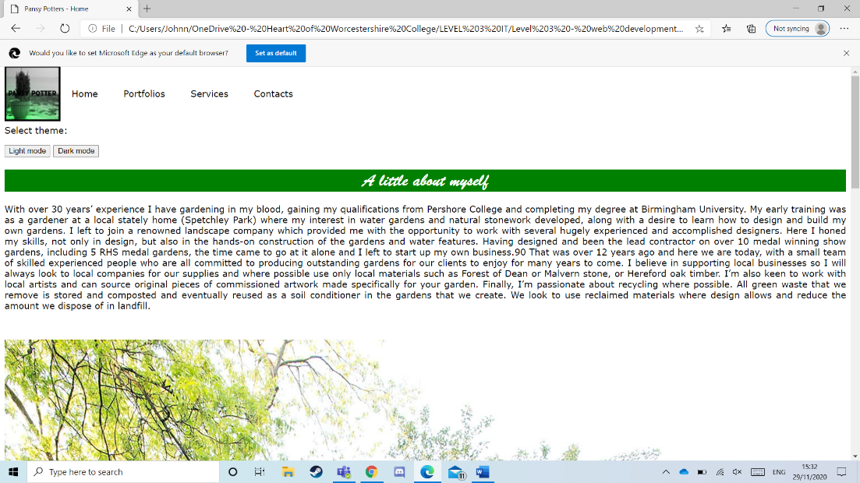**6)**

## 

**7)**

## 

**8)**

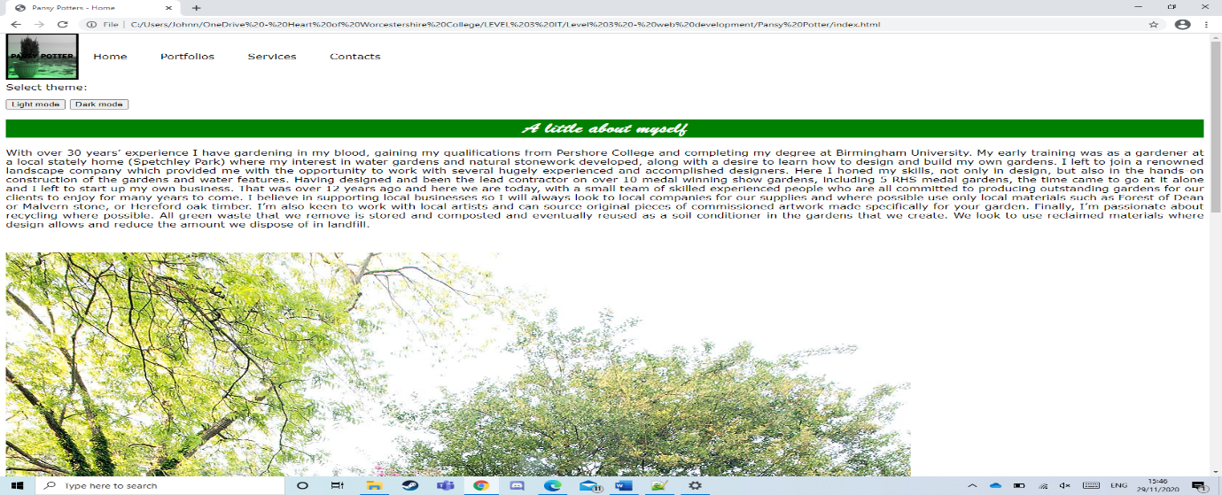

**9)**

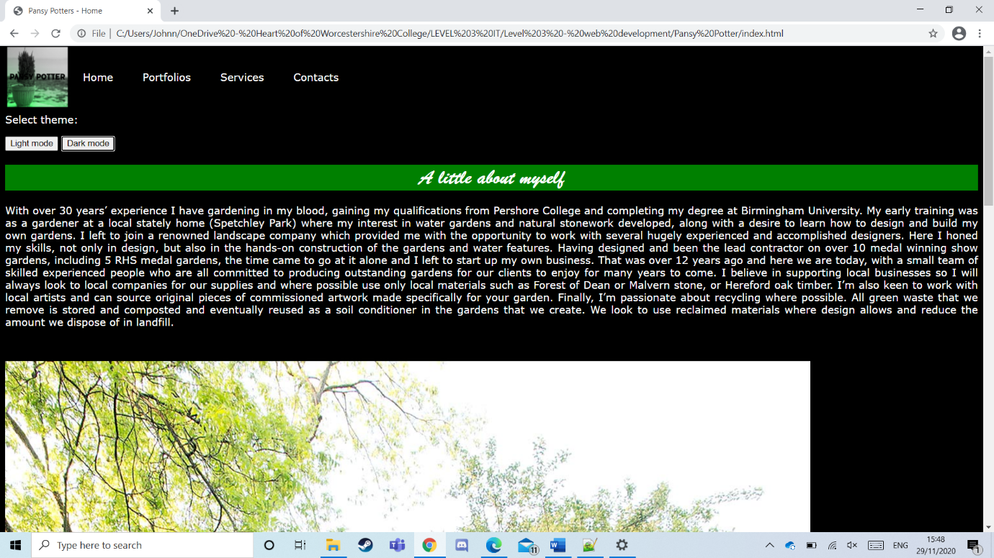**10)**

## Optimisation [M3]

Following on from the user feedback and testing, the following improvements were made:

I was told that my styling was poor as there was no colour or images. I went away and made some big changes. Here are the before and after:

As you can see, the before image was pure black with no life. Whereas the after image has pictures and green colour, to represent gardens.

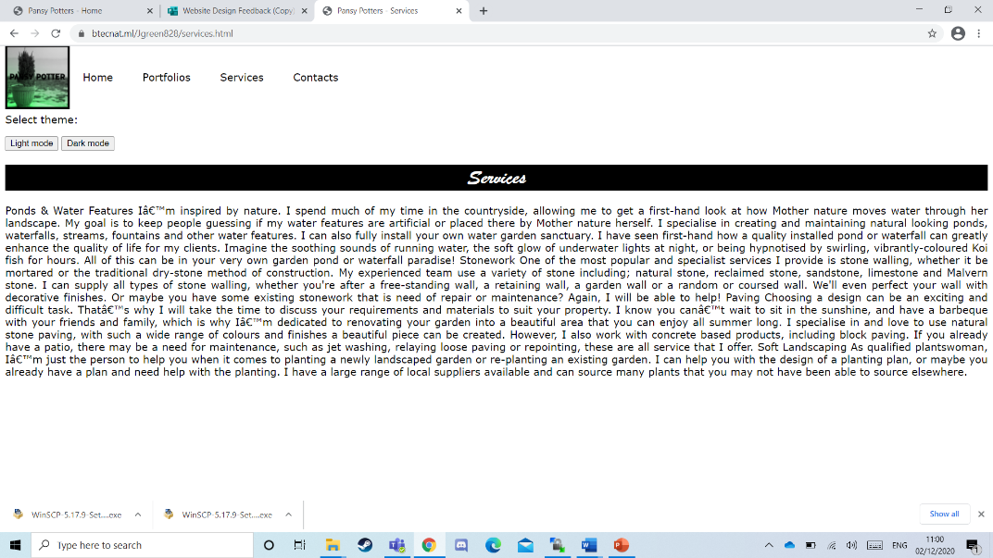I was also notified that my text layout was poor as there were typos and it wasn’t spaced out. I do agree that these are issues as it makes the page look dull and unprofessional, leading to people clicking 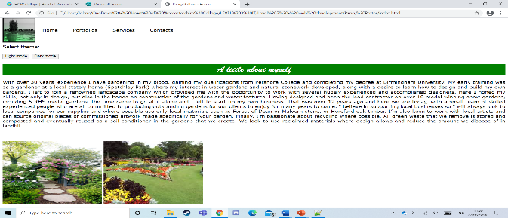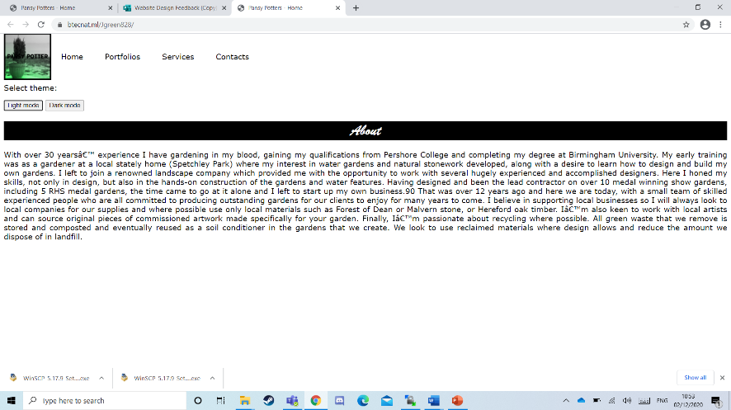off the site. As you can see from the image on the left, it is in one whole paragraph with a load of typos. However, with the image below the image on the left, you can clearly see that I have spaced out the paragraphs, and added headings. Also, I was criticised for not adding images, so I added images onto each particular service.

# 

Furthermore, Thomas and Rad pointed out that my dark mode did not work at all. It turns out that I had missed a key bit of code that made it impossible to load up the stylesheets. The code missing was “<link id="stylesheet" rel="stylesheet" href="css/style.css"/>. Which, if you would look a the images below, I have added it and it now works fine.

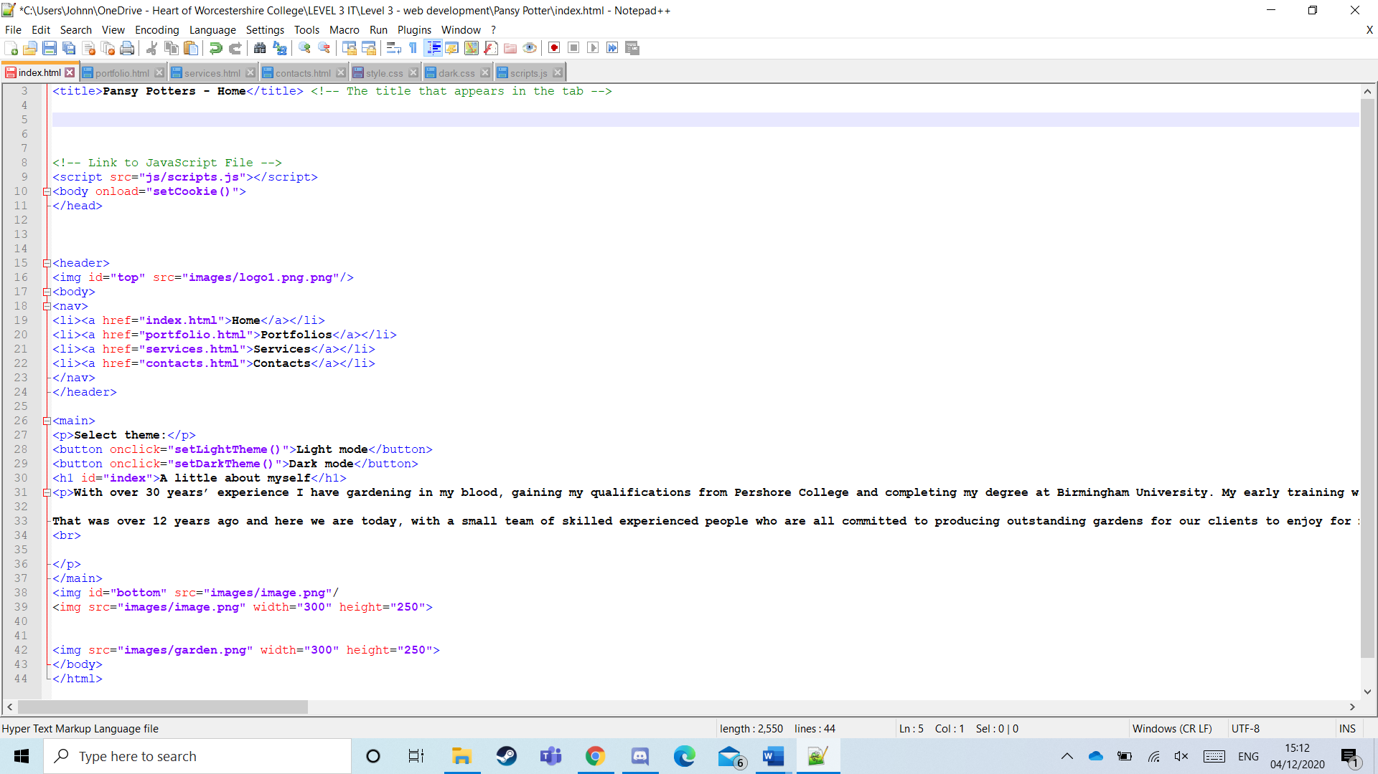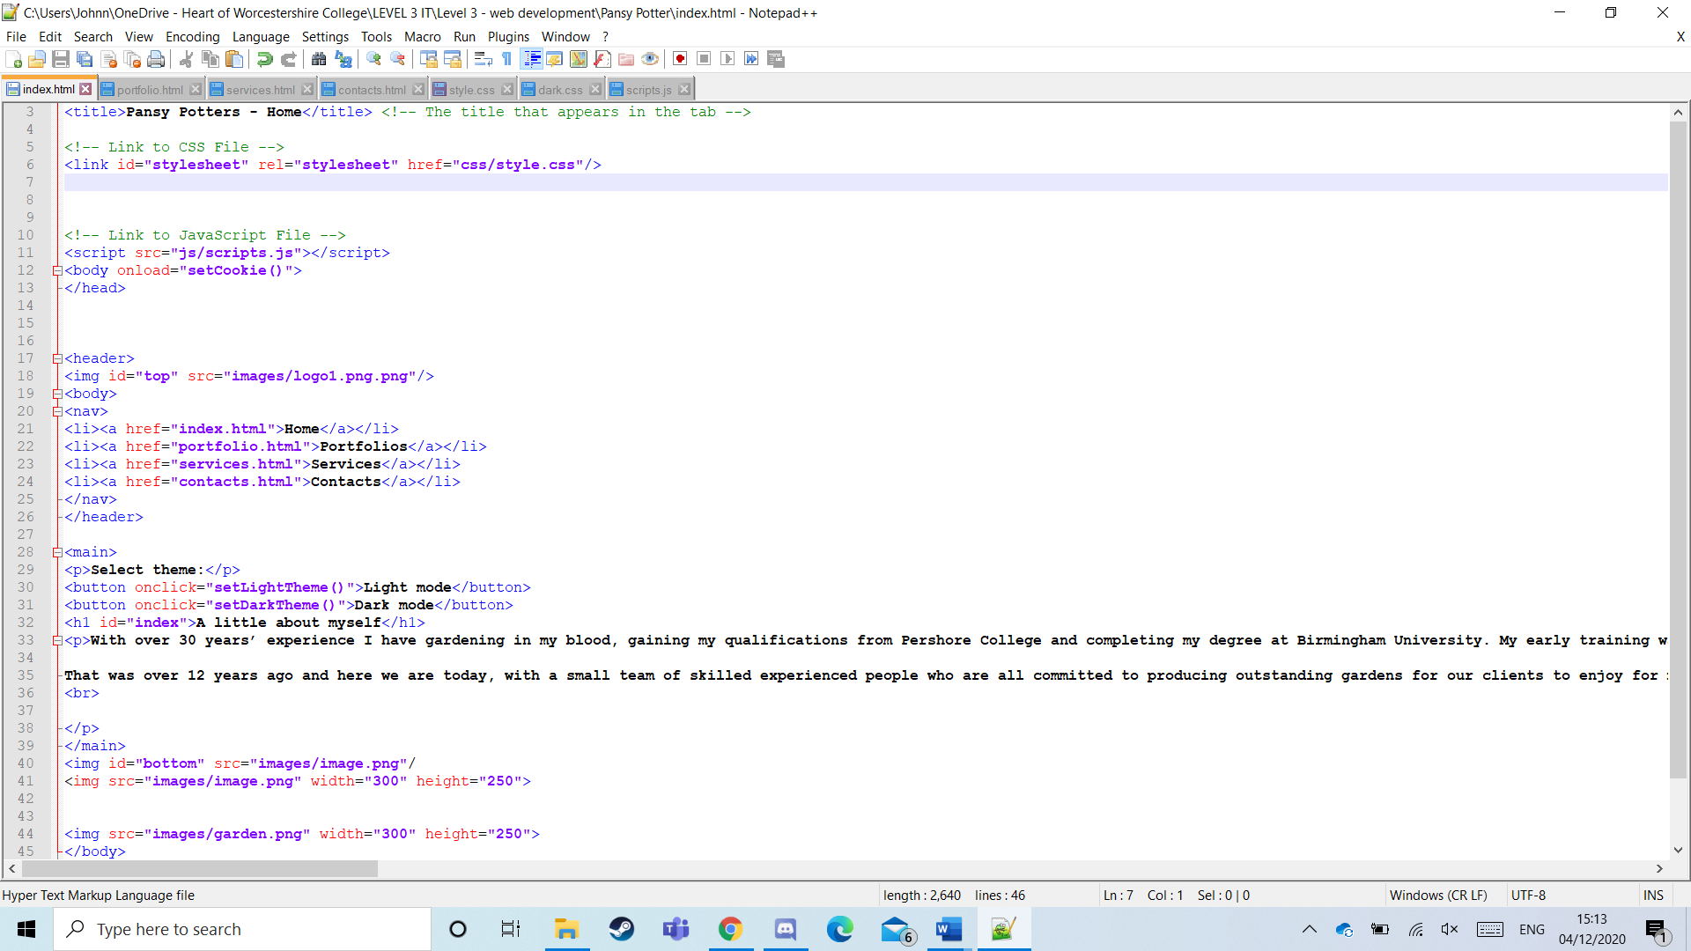

Continuously, the result in adding that code changed the website drastically. Before, the page looked very bland and dull. But after I added it, it looked pretty good. Before and after are as follows:

# 

# Task 2

## Evaluation [D2 only]

Blah blah blah

## Reflections [D3 only]

### Individual responsibility

Blah blah blah

### Creativity

Blah blah blah

### Effective self-management

Blah blah blah

## Review [P6]

I believe that the website I produced does meet the initial project brief as I have included all the content needed to, and I have the site working perfectly. The navigation works perfectly, and I have linked her socials as well. I have laid out the content in a neat fashion, making it easy and eye appealing to read.

I decided to give the website viewers a varied choice. I gave them light and dark mode to choose from, so they could use their personal preference. That affected the website a lot as I had to make two separate style sheets with inverted colours. It took me a while to figure out how to manage to code it, but once I got it under control, it felt rewarding.

A positive that I like about the website is that I included a wide array of images to match the text on screen. I think having visual aid along side writing helps to keep it in the mind. It’s also a good way of showcasing the work Pansy could provide.

A negative about the website might be that it is quite simple in design. Being simple isn’t necessarily bad, but I could have made it look flashier.

Furthermore, I could have added in slideshows, showcasing garden images through that. Adding in some gifs would help appeal to the younger audience, and it would make the site look fresh.